# 按第四级行业细分交叉验证结果

（邮件说明仅关心烧钱率模型，对应模型3）

## Semiconductors and Semiconductor Equipment

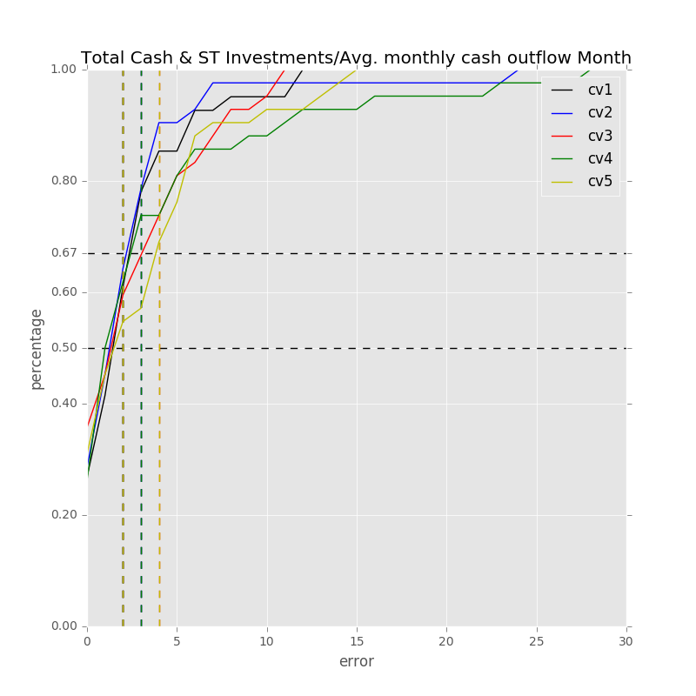

Samples: 418

Label: Total Cash & ST Investments/Avg. monthly cash outflow Month

Min Error: 0.000103

Mean Error: 3.987496

Median Error: 2.567446

Max Error: 40.142051

Feature importance:

Net Income Margin % : 0.022837

Cash from Ops./Net Income% : 0.020932

Rev YOY % : 0.020509

Total Asset Turnover : 0.020380

Gross Margin % : 0.020237

Avg. Days Payable Out. (Days): 0.020087

Total Liabilities/Total Assets % : 0.019089

Capital Expenditure ($USDmm, Current rate): 0.018410

Cash from Ops./EBITDA % : 0.018242

R&D Exp./Total Revenue % : 0.018205

Avg. Cash Conversion Cycle (Days): 0.018006

Avg. Days Inventory Out. (Days): 0.017962

EBITDA Margin % : 0.017697

Net Property, Plant & Equipment/ Total Assets % : 0.017682

Depreciation & Amort., Total ($USDmm, Current rate): 0.017069

Return on Assets % : 0.016849

Avg. Days Sales Out. (Days): 0.016208

Net Income ($USDmm, Current rate): 0.016190

Total Assets ($USDmm, Current rate): 0.015617

Total Debt/Equity % : 0.015224

Net Property, Plant & Equipment ($USDmm, Current rate): 0.015120

Cash from Ops. ($USDmm, Current rate): 0.014446

Other Operating Exp. Total ($USDmm, Current rate): 0.014164

Total Liabilities ($USDmm, Current rate): 0.013503

Return on Equity % : 0.013479

R&D Exp. ($USDmm, Current rate): 0.012912

EBITDA ($USDmm, Current rate): 0.012862

Repurchase of Common Stock ($USDmm, Current rate): 0.012284

Cost Of Goods Sold ($USDmm, Current rate): 0.012175

Total Revenue ($USDmm, Current rate): 0.012023

Goodwill/Total Revenue % : 0.011711

Cash Acquisitions ($USDmm, Current rate): 0.010593

Goodwill ($USDmm, Current rate): 0.010409

Payout Ratio (%): 0.010247

Cash Acquisitions/Total Revenue % : 0.008921

Year Founded: 0.007553

Number of Employees / Total Revenue [LTM] (Latest): 0.006658

Issuer Credit Rating - Foreign Currency LT [Latest] (Rating): 0.005028

Development Phase : 0.003089

准入资本市场难度: 0.002306

Share Bonus : 0.001549

Cash flow risk(0:low; 1: high): 0.000536

Industry Dummy: 0.000000

Label: Total Cash & ST Investments/Avg. monthly cash outflow Month

Min Error: 0.004313

Mean Error: 2.951822

Median Error: 2.247432

Max Error: 24.402914

Feature importance:

Rev YOY % : 0.024995

Cash from Ops./Net Income% : 0.022550

R&D Exp./Total Revenue % : 0.021374

Cash from Ops./EBITDA % : 0.020800

Total Asset Turnover : 0.019711

Net Income Margin % : 0.019706

Gross Margin % : 0.018733

Total Liabilities/Total Assets % : 0.018474

Return on Assets % : 0.018431

Net Property, Plant & Equipment/ Total Assets % : 0.018163

Avg. Days Payable Out. (Days): 0.018058

Capital Expenditure ($USDmm, Current rate): 0.018034

EBITDA Margin % : 0.017879

Return on Equity % : 0.017741

Avg. Cash Conversion Cycle (Days): 0.016325

Avg. Days Sales Out. (Days): 0.016303

Depreciation & Amort., Total ($USDmm, Current rate): 0.015555

Total Debt/Equity % : 0.015545

Total Liabilities ($USDmm, Current rate): 0.015103

Other Operating Exp. Total ($USDmm, Current rate): 0.014737

Repurchase of Common Stock ($USDmm, Current rate): 0.014379

Cash from Ops. ($USDmm, Current rate): 0.014355

Total Revenue ($USDmm, Current rate): 0.013831

Net Income ($USDmm, Current rate): 0.013812

EBITDA ($USDmm, Current rate): 0.013655

Payout Ratio (%): 0.013654

Goodwill/Total Revenue % : 0.013609

R&D Exp. ($USDmm, Current rate): 0.013280

Total Assets ($USDmm, Current rate): 0.013279

Net Property, Plant & Equipment ($USDmm, Current rate): 0.013165

Avg. Days Inventory Out. (Days): 0.012636

Cash Acquisitions ($USDmm, Current rate): 0.012606

Cost Of Goods Sold ($USDmm, Current rate): 0.011835

Goodwill ($USDmm, Current rate): 0.011395

Cash Acquisitions/Total Revenue % : 0.011360

Number of Employees / Total Revenue [LTM] (Latest): 0.008641

Year Founded: 0.007516

Issuer Credit Rating - Foreign Currency LT [Latest] (Rating): 0.004192

准入资本市场难度: 0.003142

Development Phase : 0.002290

Share Bonus : 0.001331

Cash flow risk(0:low; 1: high): 0.000822

Industry Dummy: 0.000000

Label: Total Cash & ST Investments/Avg. monthly cash outflow Month

Min Error: 0.000000

Mean Error: 3.333858

Median Error: 2.541125

Max Error: 11.570253

Feature importance:

Net Income Margin % : 0.022779

Total Asset Turnover : 0.022704

Cash from Ops./Net Income% : 0.022237

Total Liabilities/Total Assets % : 0.022102

Rev YOY % : 0.022083

Avg. Cash Conversion Cycle (Days): 0.021658

Avg. Days Inventory Out. (Days): 0.019063

Cash from Ops./EBITDA % : 0.018597

Avg. Days Payable Out. (Days): 0.018352

EBITDA Margin % : 0.018306

Capital Expenditure ($USDmm, Current rate): 0.018282

Gross Margin % : 0.017488

Return on Assets % : 0.017395

Return on Equity % : 0.017359

Net Property, Plant & Equipment/ Total Assets % : 0.017013

Avg. Days Sales Out. (Days): 0.016984

Cash from Ops. ($USDmm, Current rate): 0.016934

R&D Exp./Total Revenue % : 0.015792

Net Income ($USDmm, Current rate): 0.015370

Repurchase of Common Stock ($USDmm, Current rate): 0.015180

Total Debt/Equity % : 0.014364

Cost Of Goods Sold ($USDmm, Current rate): 0.014306

Depreciation & Amort., Total ($USDmm, Current rate): 0.014253

EBITDA ($USDmm, Current rate): 0.013968

Other Operating Exp. Total ($USDmm, Current rate): 0.013847

Net Property, Plant & Equipment ($USDmm, Current rate): 0.013109

Total Revenue ($USDmm, Current rate): 0.012706

Total Liabilities ($USDmm, Current rate): 0.012465

Total Assets ($USDmm, Current rate): 0.012178

Goodwill/Total Revenue % : 0.011969

R&D Exp. ($USDmm, Current rate): 0.011586

Payout Ratio (%): 0.010302

Cash Acquisitions/Total Revenue % : 0.010201

Number of Employees / Total Revenue [LTM] (Latest): 0.009999

Goodwill ($USDmm, Current rate): 0.009528

Cash Acquisitions ($USDmm, Current rate): 0.008183

Year Founded: 0.007851

Issuer Credit Rating - Foreign Currency LT [Latest] (Rating): 0.005225

Development Phase : 0.002907

准入资本市场难度: 0.002377

Share Bonus : 0.001497

Cash flow risk(0:low; 1: high): 0.000499

Industry Dummy: 0.000000

Label: Total Cash & ST Investments/Avg. monthly cash outflow Month

Min Error: 0.004434

Mean Error: 4.266007

Median Error: 1.995376

Max Error: 28.745088

Feature importance:

Net Income Margin % : 0.022793

Gross Margin % : 0.021727

Cash from Ops./Net Income% : 0.021067

Cash from Ops./EBITDA % : 0.020409

Total Asset Turnover : 0.020406

Rev YOY % : 0.020145

Avg. Days Payable Out. (Days): 0.020091

Return on Assets % : 0.019357

Return on Equity % : 0.019341

Total Debt/Equity % : 0.018520

Total Liabilities/Total Assets % : 0.018262

Avg. Cash Conversion Cycle (Days): 0.018203

Net Property, Plant & Equipment/ Total Assets % : 0.018060

Capital Expenditure ($USDmm, Current rate): 0.017998

Avg. Days Inventory Out. (Days): 0.017833

Avg. Days Sales Out. (Days): 0.017665

Depreciation & Amort., Total ($USDmm, Current rate): 0.016927

R&D Exp./Total Revenue % : 0.016912

Total Revenue ($USDmm, Current rate): 0.016504

EBITDA Margin % : 0.016316

Other Operating Exp. Total ($USDmm, Current rate): 0.014951

Total Liabilities ($USDmm, Current rate): 0.014850

R&D Exp. ($USDmm, Current rate): 0.014811

Net Income ($USDmm, Current rate): 0.014756

Repurchase of Common Stock ($USDmm, Current rate): 0.014544

Cash from Ops. ($USDmm, Current rate): 0.014252

EBITDA ($USDmm, Current rate): 0.013772

Net Property, Plant & Equipment ($USDmm, Current rate): 0.013754

Total Assets ($USDmm, Current rate): 0.013470

Cost Of Goods Sold ($USDmm, Current rate): 0.013281

Goodwill/Total Revenue % : 0.012977

Number of Employees / Total Revenue [LTM] (Latest): 0.011318

Payout Ratio (%): 0.011278

Goodwill ($USDmm, Current rate): 0.011253

Cash Acquisitions/Total Revenue % : 0.010544

Cash Acquisitions ($USDmm, Current rate): 0.008398

Year Founded: 0.007415

Issuer Credit Rating - Foreign Currency LT [Latest] (Rating): 0.004418

Development Phase : 0.002342

准入资本市场难度: 0.002173

Share Bonus : 0.000999

Cash flow risk(0:low; 1: high): 0.000907

Industry Dummy: 0.000000

Label: Total Cash & ST Investments/Avg. monthly cash outflow Month

Min Error: 0.000100

Mean Error: 3.833951

Median Error: 2.714133

Max Error: 15.134039

Feature importance:

Rev YOY % : 0.024612

Net Income Margin % : 0.023990

Net Property, Plant & Equipment/ Total Assets % : 0.021644

Cash from Ops./EBITDA % : 0.021277

Total Liabilities/Total Assets % : 0.021119

Cash from Ops./Net Income% : 0.020997

Return on Equity % : 0.020711

Capital Expenditure ($USDmm, Current rate): 0.020040

Avg. Days Payable Out. (Days): 0.020030

Return on Assets % : 0.019991

Total Asset Turnover : 0.019791

Gross Margin % : 0.019415

EBITDA Margin % : 0.019409

Avg. Cash Conversion Cycle (Days): 0.019122

Avg. Days Inventory Out. (Days): 0.018985

Other Operating Exp. Total ($USDmm, Current rate): 0.017717

Total Debt/Equity % : 0.017190

R&D Exp./Total Revenue % : 0.017032

Cash from Ops. ($USDmm, Current rate): 0.016745

Repurchase of Common Stock ($USDmm, Current rate): 0.016626

Total Liabilities ($USDmm, Current rate): 0.016350

Avg. Days Sales Out. (Days): 0.015459

Depreciation & Amort., Total ($USDmm, Current rate): 0.015373

Total Assets ($USDmm, Current rate): 0.014958

Net Income ($USDmm, Current rate): 0.014696

Total Revenue ($USDmm, Current rate): 0.014527

Number of Employees / Total Revenue [LTM] (Latest): 0.014501

Net Property, Plant & Equipment ($USDmm, Current rate): 0.014076

R&D Exp. ($USDmm, Current rate): 0.013713

Cost Of Goods Sold ($USDmm, Current rate): 0.012843

EBITDA ($USDmm, Current rate): 0.012597

Goodwill/Total Revenue % : 0.012416

Payout Ratio (%): 0.011239

Year Founded: 0.009793

Cash Acquisitions ($USDmm, Current rate): 0.009353

Goodwill ($USDmm, Current rate): 0.009107

Cash Acquisitions/Total Revenue % : 0.008690

Issuer Credit Rating - Foreign Currency LT [Latest] (Rating): 0.004930

准入资本市场难度: 0.003197

Development Phase : 0.003148

Share Bonus : 0.001092

Cash flow risk(0:low; 1: high): 0.000500

Industry Dummy: 0.000000

Total Min: 0.001790

Total Mean: 3.674627

Total Median: 2.413102

Total Max: 23.998869

## Software and Services

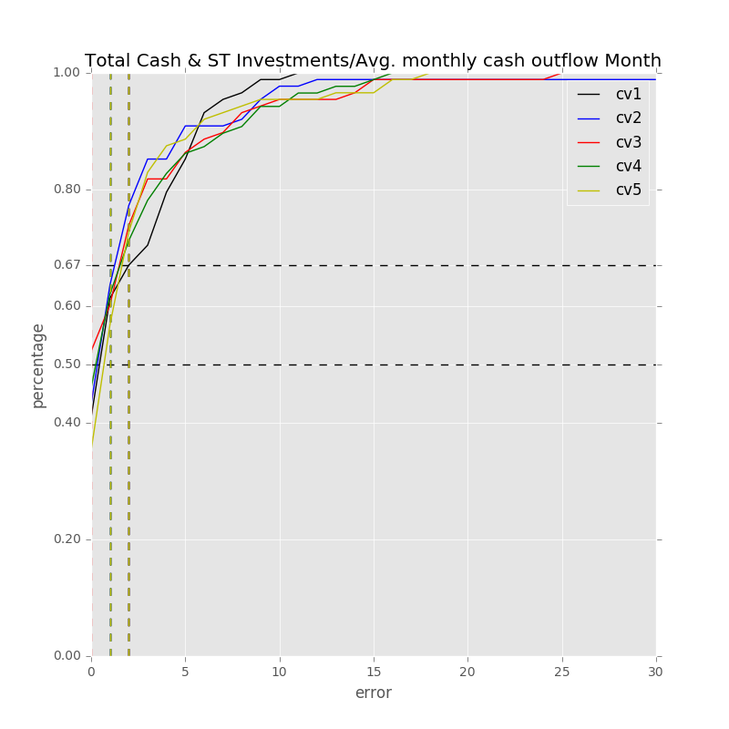

Samples: 873

Label: Total Cash & ST Investments/Avg. monthly cash outflow Month

Min Error: 0.000175

Mean Error: 2.562961

Median Error: 1.457235

Max Error: 11.069970

Feature importance:

Net Income Margin % : 0.043923

Rev YOY % : 0.037546

EBITDA Margin % : 0.036941

Cash from Ops./EBITDA % : 0.033712

Total Liabilities/Total Assets % : 0.032707

Total Revenue ($USDmm, Current rate): 0.031247

Cash from Ops./Net Income% : 0.030970

Gross Margin % : 0.030561

Avg. Cash Conversion Cycle (Days): 0.028888

Total Asset Turnover : 0.028722

Return on Assets % : 0.028567

Net Income ($USDmm, Current rate): 0.028519

EBITDA ($USDmm, Current rate): 0.028365

Avg. Days Sales Out. (Days): 0.027798

Capital Expenditure ($USDmm, Current rate): 0.027561

Depreciation & Amort., Total ($USDmm, Current rate): 0.027152

Return on Equity % : 0.027135

Number of Employees / Total Revenue [LTM] (Latest): 0.026434

Total Liabilities ($USDmm, Current rate): 0.026422

Goodwill/Total Revenue % : 0.025504

Cash Acquisitions ($USDmm, Current rate): 0.025109

Net Property, Plant & Equipment ($USDmm, Current rate): 0.024681

Total Debt/Equity % : 0.024624

Year Founded: 0.024510

Net Property, Plant & Equipment/ Total Assets % : 0.024019

Other Operating Exp. Total ($USDmm, Current rate): 0.023373

Cash Acquisitions/Total Revenue % : 0.023318

Total Assets ($USDmm, Current rate): 0.023197

Cost Of Goods Sold ($USDmm, Current rate): 0.022773

Avg. Days Payable Out. (Days): 0.022203

Repurchase of Common Stock ($USDmm, Current rate): 0.021660

Goodwill ($USDmm, Current rate): 0.020966

R&D Exp./Total Revenue % : 0.020958

Cash from Ops. ($USDmm, Current rate): 0.020006

Payout Ratio (%): 0.017445

R&D Exp. ($USDmm, Current rate): 0.015739

Issuer Credit Rating - Foreign Currency LT [Latest] (Rating): 0.012484

Avg. Days Inventory Out. (Days): 0.012013

准入资本市场难度: 0.005500

Cash flow risk(0:low; 1: high): 0.002889

Development Phase : 0.002202

Share Bonus : 0.001656

Industry Dummy: 0.000000

Label: Total Cash & ST Investments/Avg. monthly cash outflow Month

Min Error: 0.000143

Mean Error: 2.589976

Median Error: 1.092884

Max Error: 40.486707

Feature importance:

Net Income Margin % : 0.042225

Rev YOY % : 0.035558

Total Liabilities/Total Assets % : 0.034899

Cash from Ops./Net Income% : 0.033931

EBITDA Margin % : 0.033794

Total Revenue ($USDmm, Current rate): 0.031798

Cash from Ops./EBITDA % : 0.031429

Return on Assets % : 0.029330

Avg. Cash Conversion Cycle (Days): 0.028291

Cash Acquisitions/Total Revenue % : 0.028177

Avg. Days Sales Out. (Days): 0.027678

Total Asset Turnover : 0.027676

Net Property, Plant & Equipment/ Total Assets % : 0.027149

Avg. Days Payable Out. (Days): 0.026970

Total Liabilities ($USDmm, Current rate): 0.026706

Number of Employees / Total Revenue [LTM] (Latest): 0.026348

Other Operating Exp. Total ($USDmm, Current rate): 0.026280

Net Income ($USDmm, Current rate): 0.026239

Capital Expenditure ($USDmm, Current rate): 0.026230

Gross Margin % : 0.026006

Total Assets ($USDmm, Current rate): 0.025926

Cash from Ops. ($USDmm, Current rate): 0.025879

Depreciation & Amort., Total ($USDmm, Current rate): 0.025877

Net Property, Plant & Equipment ($USDmm, Current rate): 0.025662

Return on Equity % : 0.025043

R&D Exp./Total Revenue % : 0.024919

Cash Acquisitions ($USDmm, Current rate): 0.024777

Goodwill/Total Revenue % : 0.023152

Repurchase of Common Stock ($USDmm, Current rate): 0.022836

Year Founded: 0.022685

Cost Of Goods Sold ($USDmm, Current rate): 0.022506

Goodwill ($USDmm, Current rate): 0.021044

EBITDA ($USDmm, Current rate): 0.020952

R&D Exp. ($USDmm, Current rate): 0.018888

Payout Ratio (%): 0.018622

Total Debt/Equity % : 0.018067

Avg. Days Inventory Out. (Days): 0.012622

Issuer Credit Rating - Foreign Currency LT [Latest] (Rating): 0.009690

准入资本市场难度: 0.004995

Development Phase : 0.003473

Cash flow risk(0:low; 1: high): 0.003119

Share Bonus : 0.002556

Industry Dummy: 0.000000

Label: Total Cash & ST Investments/Avg. monthly cash outflow Month

Min Error: 0.000030

Mean Error: 2.635187

Median Error: 0.916817

Max Error: 25.738206

Feature importance:

Rev YOY % : 0.040928

Net Income Margin % : 0.039956

Cash from Ops./EBITDA % : 0.037807

EBITDA Margin % : 0.035024

Cash from Ops./Net Income% : 0.032514

Gross Margin % : 0.032045

Total Liabilities/Total Assets % : 0.030810

Avg. Days Sales Out. (Days): 0.029893

Capital Expenditure ($USDmm, Current rate): 0.029274

Avg. Cash Conversion Cycle (Days): 0.029060

Return on Assets % : 0.028655

Total Revenue ($USDmm, Current rate): 0.028410

Cash Acquisitions/Total Revenue % : 0.027772

Total Asset Turnover : 0.027162

Net Property, Plant & Equipment/ Total Assets % : 0.026324

Goodwill ($USDmm, Current rate): 0.026066

Return on Equity % : 0.025950

Goodwill/Total Revenue % : 0.025583

Repurchase of Common Stock ($USDmm, Current rate): 0.025416

Depreciation & Amort., Total ($USDmm, Current rate): 0.025378

Total Liabilities ($USDmm, Current rate): 0.025216

Net Property, Plant & Equipment ($USDmm, Current rate): 0.024987

R&D Exp./Total Revenue % : 0.024946

Cash Acquisitions ($USDmm, Current rate): 0.024752

Cash from Ops. ($USDmm, Current rate): 0.024540

Other Operating Exp. Total ($USDmm, Current rate): 0.024421

Total Assets ($USDmm, Current rate): 0.023547

Net Income ($USDmm, Current rate): 0.023503

Total Debt/Equity % : 0.022787

Avg. Days Payable Out. (Days): 0.022603

EBITDA ($USDmm, Current rate): 0.022597

Cost Of Goods Sold ($USDmm, Current rate): 0.022166

Number of Employees / Total Revenue [LTM] (Latest): 0.020921

Year Founded: 0.018687

R&D Exp. ($USDmm, Current rate): 0.016274

Payout Ratio (%): 0.016074

Issuer Credit Rating - Foreign Currency LT [Latest] (Rating): 0.012735

Avg. Days Inventory Out. (Days): 0.011282

准入资本市场难度: 0.006671

Cash flow risk(0:low; 1: high): 0.003108

Development Phase : 0.002613

Share Bonus : 0.001545

Industry Dummy: 0.000000

Label: Total Cash & ST Investments/Avg. monthly cash outflow Month

Min Error: 0.000197

Mean Error: 3.182055

Median Error: 1.234075

Max Error: 46.140996

Feature importance:

Net Income Margin % : 0.039029

Rev YOY % : 0.038627

Cash from Ops./EBITDA % : 0.037578

EBITDA Margin % : 0.034690

Total Liabilities/Total Assets % : 0.033212

Number of Employees / Total Revenue [LTM] (Latest): 0.030968

Cash from Ops./Net Income% : 0.030247

Return on Assets % : 0.029804

Net Property, Plant & Equipment/ Total Assets % : 0.029796

Return on Equity % : 0.029582

Goodwill/Total Revenue % : 0.029074

Total Revenue ($USDmm, Current rate): 0.028753

Gross Margin % : 0.028591

Avg. Days Sales Out. (Days): 0.028529

Avg. Days Payable Out. (Days): 0.027850

Cash Acquisitions/Total Revenue % : 0.027539

Avg. Cash Conversion Cycle (Days): 0.027275

Depreciation & Amort., Total ($USDmm, Current rate): 0.026171

Capital Expenditure ($USDmm, Current rate): 0.026084

Total Asset Turnover : 0.025870

Net Income ($USDmm, Current rate): 0.025073

Other Operating Exp. Total ($USDmm, Current rate): 0.024751

Total Assets ($USDmm, Current rate): 0.024559

Cash Acquisitions ($USDmm, Current rate): 0.024247

Total Liabilities ($USDmm, Current rate): 0.023935

Repurchase of Common Stock ($USDmm, Current rate): 0.023379

EBITDA ($USDmm, Current rate): 0.023192

Net Property, Plant & Equipment ($USDmm, Current rate): 0.023183

Cost Of Goods Sold ($USDmm, Current rate): 0.022149

Year Founded: 0.021926

Cash from Ops. ($USDmm, Current rate): 0.020960

Goodwill ($USDmm, Current rate): 0.020766

R&D Exp./Total Revenue % : 0.020424

Total Debt/Equity % : 0.019226

R&D Exp. ($USDmm, Current rate): 0.017648

Payout Ratio (%): 0.017456

Issuer Credit Rating - Foreign Currency LT [Latest] (Rating): 0.012046

Avg. Days Inventory Out. (Days): 0.010524

准入资本市场难度: 0.005534

Development Phase : 0.003675

Cash flow risk(0:low; 1: high): 0.003230

Share Bonus : 0.002847

Industry Dummy: 0.000000

Label: Total Cash & ST Investments/Avg. monthly cash outflow Month

Min Error: 0.000243

Mean Error: 2.694337

Median Error: 1.662186

Max Error: 18.846458

Feature importance:

Rev YOY % : 0.042956

Net Income Margin % : 0.037698

EBITDA Margin % : 0.035142

Avg. Days Sales Out. (Days): 0.033941

Cash from Ops./EBITDA % : 0.032753

Total Liabilities/Total Assets % : 0.032613

Cash from Ops./Net Income% : 0.031387

Depreciation & Amort., Total ($USDmm, Current rate): 0.029678

Return on Assets % : 0.029018

Other Operating Exp. Total ($USDmm, Current rate): 0.028431

Number of Employees / Total Revenue [LTM] (Latest): 0.027838

Total Revenue ($USDmm, Current rate): 0.027667

Capital Expenditure ($USDmm, Current rate): 0.026696

Cash Acquisitions/Total Revenue % : 0.026695

Gross Margin % : 0.026610

EBITDA ($USDmm, Current rate): 0.026389

Cash Acquisitions ($USDmm, Current rate): 0.025648

Avg. Cash Conversion Cycle (Days): 0.025500

Net Property, Plant & Equipment ($USDmm, Current rate): 0.025416

Return on Equity % : 0.025346

Cash from Ops. ($USDmm, Current rate): 0.025283

Total Assets ($USDmm, Current rate): 0.025255

Cost Of Goods Sold ($USDmm, Current rate): 0.025093

Year Founded: 0.024559

Repurchase of Common Stock ($USDmm, Current rate): 0.024391

Total Asset Turnover : 0.024178

Net Income ($USDmm, Current rate): 0.024163

Avg. Days Payable Out. (Days): 0.023921

Total Liabilities ($USDmm, Current rate): 0.023840

Total Debt/Equity % : 0.023227

Net Property, Plant & Equipment/ Total Assets % : 0.023080

Goodwill/Total Revenue % : 0.021304

R&D Exp./Total Revenue % : 0.020865

Goodwill ($USDmm, Current rate): 0.020313

R&D Exp. ($USDmm, Current rate): 0.018004

Payout Ratio (%): 0.015726

Avg. Days Inventory Out. (Days): 0.014474

Issuer Credit Rating - Foreign Currency LT [Latest] (Rating): 0.009748

准入资本市场难度: 0.005942

Development Phase : 0.003436

Share Bonus : 0.003144

Cash flow risk(0:low; 1: high): 0.002633

Industry Dummy: 0.000000

Total Min: 0.000157

Total Mean: 2.732903

Total Median: 1.272639

Total Max: 28.456467

## Technology Hardware and Equipment

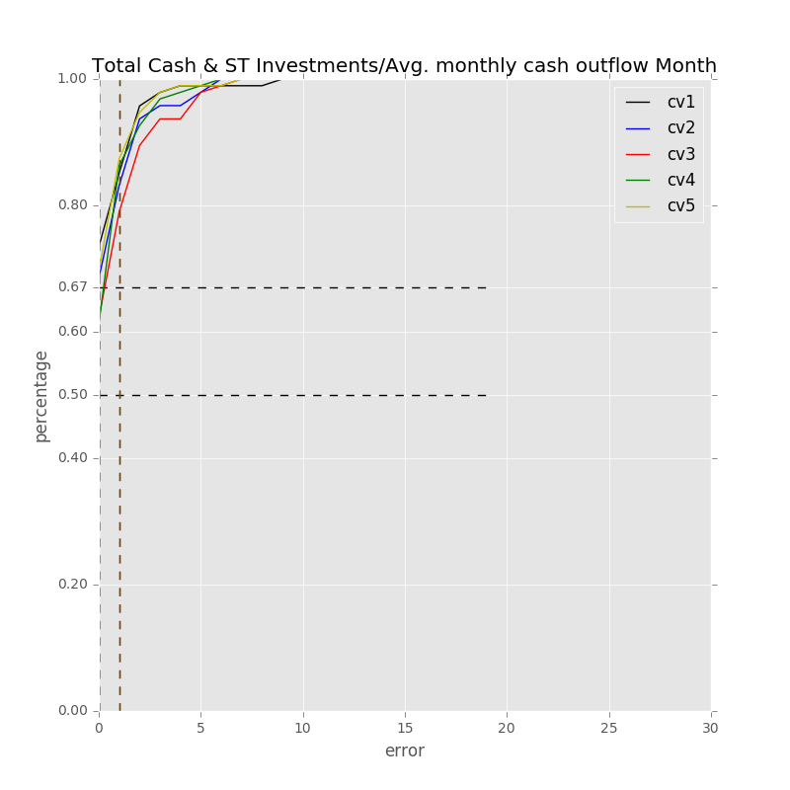

Samples: 949

Label: Total Cash & ST Investments/Avg. monthly cash outflow Month

Min Error: 0.000047

Mean Error: 1.084141

Median Error: 0.434839

Max Error: 18.993664

Feature importance:

Rev YOY % : 0.034920

Net Property, Plant & Equipment/ Total Assets % : 0.034786

Cash from Ops./EBITDA % : 0.032911

Net Income Margin % : 0.032904

Cash from Ops./Net Income% : 0.032214

Avg. Days Sales Out. (Days): 0.032083

Avg. Days Payable Out. (Days): 0.032038

Total Liabilities/Total Assets % : 0.031874

Avg. Cash Conversion Cycle (Days): 0.031690

Gross Margin % : 0.029279

Return on Assets % : 0.029229

Total Asset Turnover : 0.029001

Avg. Days Inventory Out. (Days): 0.028931

EBITDA Margin % : 0.028722

Net Income ($USDmm, Current rate): 0.028569

Other Operating Exp. Total ($USDmm, Current rate): 0.028490

Return on Equity % : 0.028199

EBITDA ($USDmm, Current rate): 0.027309

Depreciation & Amort., Total ($USDmm, Current rate): 0.027258

Capital Expenditure ($USDmm, Current rate): 0.026773

Total Debt/Equity % : 0.026717

Cost Of Goods Sold ($USDmm, Current rate): 0.026311

Total Liabilities ($USDmm, Current rate): 0.026164

Total Revenue ($USDmm, Current rate): 0.024676

Total Assets ($USDmm, Current rate): 0.024368

Payout Ratio (%): 0.024192

Net Property, Plant & Equipment ($USDmm, Current rate): 0.022916

R&D Exp./Total Revenue % : 0.022722

Cash from Ops. ($USDmm, Current rate): 0.022315

Cash Acquisitions/Total Revenue % : 0.020820

Goodwill ($USDmm, Current rate): 0.020778

Repurchase of Common Stock ($USDmm, Current rate): 0.020128

Cash Acquisitions ($USDmm, Current rate): 0.019967

R&D Exp. ($USDmm, Current rate): 0.019710

Goodwill/Total Revenue % : 0.019260

Number of Employees / Total Revenue [LTM] (Latest): 0.017472

Year Founded: 0.014794

Issuer Credit Rating - Foreign Currency LT [Latest] (Rating): 0.007341

准入资本市场难度: 0.004698

Development Phase : 0.003478

Share Bonus : 0.002483

Cash flow risk(0:low; 1: high): 0.001507

Industry Dummy: 0.000000

Label: Total Cash & ST Investments/Avg. monthly cash outflow Month

Min Error: 0.000113

Mean Error: 0.978800

Median Error: 0.475585

Max Error: 6.364997

Feature importance:

Cash from Ops./Net Income% : 0.036267

Total Debt/Equity % : 0.034524

Avg. Days Payable Out. (Days): 0.034243

Total Liabilities/Total Assets % : 0.033809

Rev YOY % : 0.032999

Net Property, Plant & Equipment/ Total Assets % : 0.032941

Avg. Days Inventory Out. (Days): 0.031862

Return on Equity % : 0.031554

Cash from Ops./EBITDA % : 0.030810

Total Asset Turnover : 0.029960

EBITDA Margin % : 0.029801

Return on Assets % : 0.029320

Avg. Days Sales Out. (Days): 0.028694

Gross Margin % : 0.028195

Avg. Cash Conversion Cycle (Days): 0.028126

Capital Expenditure ($USDmm, Current rate): 0.027820

Net Income Margin % : 0.027687

Net Income ($USDmm, Current rate): 0.027053

Payout Ratio (%): 0.026303

Cost Of Goods Sold ($USDmm, Current rate): 0.026231

Net Property, Plant & Equipment ($USDmm, Current rate): 0.025980

Depreciation & Amort., Total ($USDmm, Current rate): 0.025900

EBITDA ($USDmm, Current rate): 0.025719

Other Operating Exp. Total ($USDmm, Current rate): 0.025152

Total Revenue ($USDmm, Current rate): 0.025003

Cash from Ops. ($USDmm, Current rate): 0.024747

Total Assets ($USDmm, Current rate): 0.024587

Total Liabilities ($USDmm, Current rate): 0.024286

R&D Exp./Total Revenue % : 0.022572

Cash Acquisitions/Total Revenue % : 0.022398

Cash Acquisitions ($USDmm, Current rate): 0.021227

Goodwill ($USDmm, Current rate): 0.019831

Repurchase of Common Stock ($USDmm, Current rate): 0.019758

Goodwill/Total Revenue % : 0.019301

Number of Employees / Total Revenue [LTM] (Latest): 0.017808

R&D Exp. ($USDmm, Current rate): 0.016153

Year Founded: 0.012475

Issuer Credit Rating - Foreign Currency LT [Latest] (Rating): 0.006653

准入资本市场难度: 0.004500

Development Phase : 0.003777

Share Bonus : 0.002697

Cash flow risk(0:low; 1: high): 0.001273

Industry Dummy: 0.000000

Label: Total Cash & ST Investments/Avg. monthly cash outflow Month

Min Error: 0.000023

Mean Error: 1.179681

Median Error: 0.544317

Max Error: 7.012359

Feature importance:

Cash from Ops./Net Income% : 0.038454

Total Liabilities/Total Assets % : 0.035570

Net Property, Plant & Equipment/ Total Assets % : 0.035200

Avg. Days Payable Out. (Days): 0.034747

Cash from Ops./EBITDA % : 0.033669

Total Asset Turnover : 0.032606

Avg. Days Sales Out. (Days): 0.031630

Avg. Cash Conversion Cycle (Days): 0.031250

Rev YOY % : 0.031153

Return on Assets % : 0.030988

Net Income Margin % : 0.030431

Total Debt/Equity % : 0.030203

Avg. Days Inventory Out. (Days): 0.029166

Return on Equity % : 0.028983

Gross Margin % : 0.028774

EBITDA Margin % : 0.028225

Net Income ($USDmm, Current rate): 0.026321

Total Revenue ($USDmm, Current rate): 0.026004

Total Liabilities ($USDmm, Current rate): 0.025807

Net Property, Plant & Equipment ($USDmm, Current rate): 0.025539

Total Assets ($USDmm, Current rate): 0.024721

Cash Acquisitions/Total Revenue % : 0.024575

Cost Of Goods Sold ($USDmm, Current rate): 0.024422

EBITDA ($USDmm, Current rate): 0.024283

Depreciation & Amort., Total ($USDmm, Current rate): 0.024031

Capital Expenditure ($USDmm, Current rate): 0.023922

Other Operating Exp. Total ($USDmm, Current rate): 0.023635

Payout Ratio (%): 0.023148

Cash from Ops. ($USDmm, Current rate): 0.023069

Repurchase of Common Stock ($USDmm, Current rate): 0.022421

R&D Exp./Total Revenue % : 0.021570

Goodwill/Total Revenue % : 0.021038

Goodwill ($USDmm, Current rate): 0.018692

Number of Employees / Total Revenue [LTM] (Latest): 0.018115

Cash Acquisitions ($USDmm, Current rate): 0.017943

R&D Exp. ($USDmm, Current rate): 0.017347

Year Founded: 0.014635

Issuer Credit Rating - Foreign Currency LT [Latest] (Rating): 0.005462

Development Phase : 0.004528

准入资本市场难度: 0.003694

Share Bonus : 0.002589

Cash flow risk(0:low; 1: high): 0.001442

Industry Dummy: 0.000000

Label: Total Cash & ST Investments/Avg. monthly cash outflow Month

Min Error: 0.000115

Mean Error: 1.058118

Median Error: 0.685250

Max Error: 6.459714

Feature importance:

Cash from Ops./EBITDA % : 0.036684

Net Property, Plant & Equipment/ Total Assets % : 0.036135

Rev YOY % : 0.035465

Cash from Ops./Net Income% : 0.033759

Total Liabilities/Total Assets % : 0.032699

Total Asset Turnover : 0.032390

Avg. Days Inventory Out. (Days): 0.031686

Avg. Days Sales Out. (Days): 0.030824

Gross Margin % : 0.030673

EBITDA Margin % : 0.029822

Net Income Margin % : 0.029566

Return on Assets % : 0.029554

Avg. Days Payable Out. (Days): 0.028601

Other Operating Exp. Total ($USDmm, Current rate): 0.027833

Net Income ($USDmm, Current rate): 0.027724

Return on Equity % : 0.027724

Capital Expenditure ($USDmm, Current rate): 0.027264

Total Debt/Equity % : 0.026729

EBITDA ($USDmm, Current rate): 0.026686

Total Assets ($USDmm, Current rate): 0.026279

Depreciation & Amort., Total ($USDmm, Current rate): 0.026087

Avg. Cash Conversion Cycle (Days): 0.025610

R&D Exp./Total Revenue % : 0.025289

Cash from Ops. ($USDmm, Current rate): 0.025240

Cost Of Goods Sold ($USDmm, Current rate): 0.024910

Total Liabilities ($USDmm, Current rate): 0.024870

Cash Acquisitions/Total Revenue % : 0.023572

Total Revenue ($USDmm, Current rate): 0.023309

Net Property, Plant & Equipment ($USDmm, Current rate): 0.021901

Repurchase of Common Stock ($USDmm, Current rate): 0.021719

Cash Acquisitions ($USDmm, Current rate): 0.021625

Goodwill/Total Revenue % : 0.021035

Payout Ratio (%): 0.020960

Number of Employees / Total Revenue [LTM] (Latest): 0.020223

Goodwill ($USDmm, Current rate): 0.018066

Year Founded: 0.016954

R&D Exp. ($USDmm, Current rate): 0.014679

Issuer Credit Rating - Foreign Currency LT [Latest] (Rating): 0.006041

Development Phase : 0.003307

准入资本市场难度: 0.003292

Share Bonus : 0.001800

Cash flow risk(0:low; 1: high): 0.001415

Industry Dummy: 0.000000

Label: Total Cash & ST Investments/Avg. monthly cash outflow Month

Min Error: 0.000014

Mean Error: 0.878233

Median Error: 0.517865

Max Error: 7.069778

Feature importance:

Rev YOY % : 0.037058

Cash from Ops./EBITDA % : 0.033285

Cash from Ops./Net Income% : 0.032911

Avg. Days Sales Out. (Days): 0.032659

Avg. Days Payable Out. (Days): 0.032551

Total Liabilities/Total Assets % : 0.032071

Net Property, Plant & Equipment/ Total Assets % : 0.031611

Gross Margin % : 0.031344

Avg. Days Inventory Out. (Days): 0.030572

Total Asset Turnover : 0.030270

Avg. Cash Conversion Cycle (Days): 0.029948

Total Debt/Equity % : 0.029839

Total Liabilities ($USDmm, Current rate): 0.029245

Cost Of Goods Sold ($USDmm, Current rate): 0.029065

Other Operating Exp. Total ($USDmm, Current rate): 0.028977

Net Income Margin % : 0.028925

Return on Assets % : 0.027881

Capital Expenditure ($USDmm, Current rate): 0.026973

Return on Equity % : 0.026973

Total Assets ($USDmm, Current rate): 0.026728

Total Revenue ($USDmm, Current rate): 0.026382

Net Income ($USDmm, Current rate): 0.026136

EBITDA ($USDmm, Current rate): 0.026123

EBITDA Margin % : 0.025704

Depreciation & Amort., Total ($USDmm, Current rate): 0.025496

R&D Exp./Total Revenue % : 0.024146

Payout Ratio (%): 0.023135

Cash from Ops. ($USDmm, Current rate): 0.022855

Net Property, Plant & Equipment ($USDmm, Current rate): 0.022456

Cash Acquisitions/Total Revenue % : 0.021871

Goodwill ($USDmm, Current rate): 0.021126

Goodwill/Total Revenue % : 0.019657

Cash Acquisitions ($USDmm, Current rate): 0.019338

Repurchase of Common Stock ($USDmm, Current rate): 0.018765

R&D Exp. ($USDmm, Current rate): 0.018194

Number of Employees / Total Revenue [LTM] (Latest): 0.017749

Year Founded: 0.016409

Issuer Credit Rating - Foreign Currency LT [Latest] (Rating): 0.005771

Development Phase : 0.003893

准入资本市场难度: 0.003172

Cash flow risk(0:low; 1: high): 0.001480

Share Bonus : 0.001256

Industry Dummy: 0.000000

Total Min: 0.000062

Total Mean: 1.035795

Total Median: 0.531571

Total Max: 9.180102